# Docusign – Document Submission Process

## Docusign Account Creation

* Who can create an account?
  + Departmental financial staff responsible for creating and submitting Relocation Authorization forms can create a Docusign account for this process. If an account is already open for UWF or Official Function submissions, then that same account can be used.
* How to create an account?
  + Email [appsupport@med.wisc.edu](mailto:appsupport@med.wisc.edu) to request Docusign account setup with your UW email address.
* Who is involved with this process?
  + Departments should process their Relocation Authorization forms this way as a faster and trackable method through the SMPH Divisional Office.
  + The signature process includes Heidi Conrad.

## Submitting A Relocation Authorization Form

* In your Docusign account, click “Start”, and upload your relocation authorization letter (as a PDF or Word document) in the “Add Documents to the Envelope” section. This needs to be completed before submission.

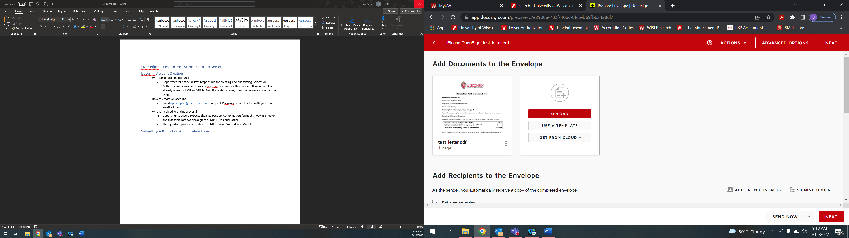

* In the “Add Recipients to the Envelope” section, add the following name and email address:
  + Heidi Conrad (email: [hgconrad@wisc.edu](mailto:hgconrad@wisc.edu))
  + HR Business Partner Name & email address (select as ‘CC’ to receive a copy of the signed document)
* In the “Message to All Recipients” section, enter the following:
  + Email Subject: Please enter the last name and relocation authorization in this box.
    - Ex: Doe Relocation Authorization
  + Email Message: Any additional information SMPH may need to be aware of.
* Once these are added, click “Next” in the bottom right-hand corner.
* Scroll down the document, and add Heidi Conrad’s Signature, Date Signed, and Title to the respective categories as shown below:

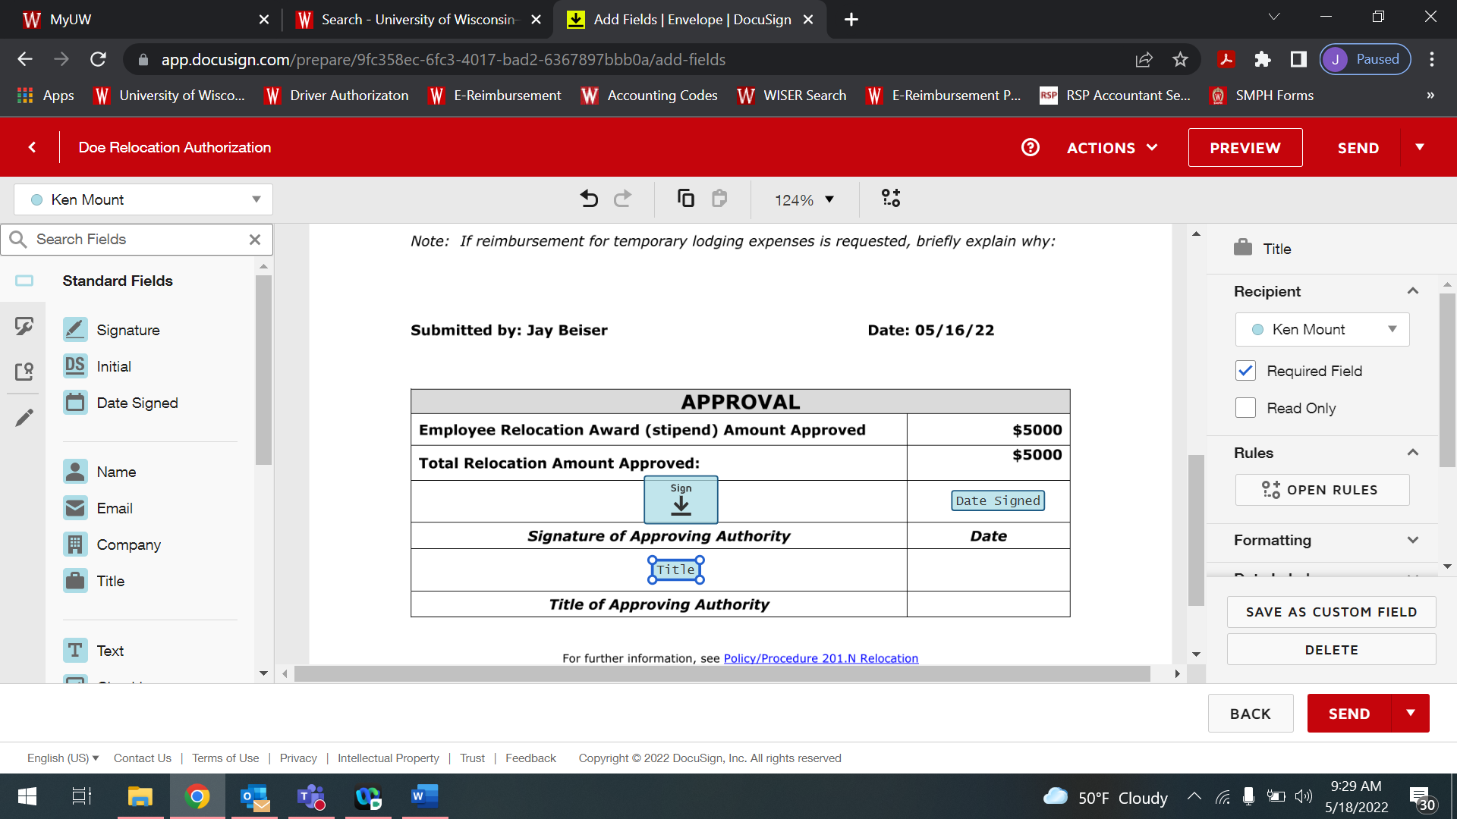

* Once all signatures are added, review the document to make sure everything is accurate, and click “Send” to send through the signature process.
* Once completed, the submitter and HR business partner will receive a fully signed copy in their Docusign account to use with related relocation stipend payment process.
  + Submitter should receive an email notification about completion.
  + If necessary, the HR Business Partner will reach out with any questions.